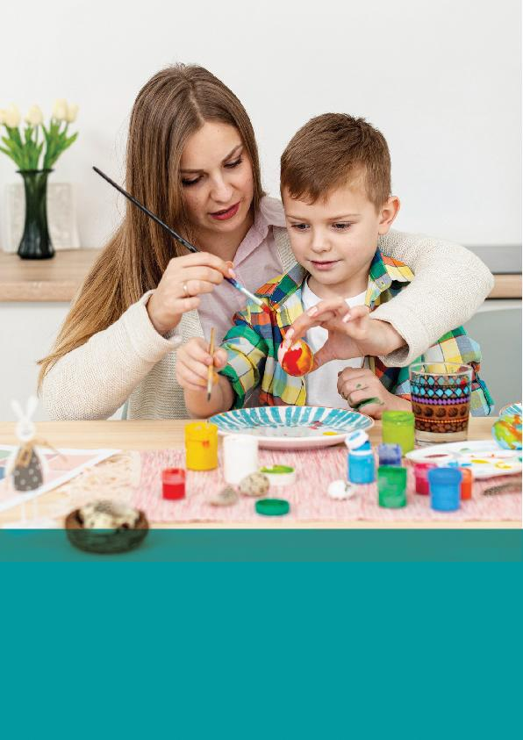

Course Name
Unit 12 - Summary

Centring the Child in Assessment and Planning
Effective assessment and planning must be child-centred. This approach places the child or young person at the heart of the process, ensuring their individual needs, preferences, and views are the critical factors in developing any support plan. The value of this model is that it empowers the child, helps them feel valued , and leads to better, more tailored outcomes. Identifying needs requires a holistic assessment that considers all aspects of a child's life: physical, emotional, social, and educational. This cannot be done by one person; it requires collaboration with others, especially the child's family and a multi-agency team (like teachers, social workers, and healthcare providers). A key part of this process is setting clear goals. You must work with the child to plan realistic, achievable, and challenging goals , often using the SMART framework (Specific, Measurable, Achievable, Relevant, and Time-bound) to provide clear direction.
Questions:
- What is the main goal of a child-centred model of assessment?
Answer: To place the child's needs, preferences, and views at the heart of the planning process.
- Why is a multi-agency approach to assessment important?
Answer: Because no single professional can understand the complexities of a child's life; it ensures the assessment is holistic.
- What does the 'A' in the SMART goal framework stand for?
Answer: Achievable.
- Name two methods for ensuring a child can participate in planning.
Answer: Any two of: play , pictures/drawing , setting ground rules , written contributions , or video/audio contributions.
- What is 'permanency planning' designed to provide for a child in care?
Answer: A stable, secure, and long-term environment.

Implementing and Reviewing the Plan
Once a plan is developed, successful implementation is the next critical phase. This requires active engagement from the child, their family, and professionals. A key step is providing clear, jargon-free information to everyone involved about their specific roles and responsibilities. You must agree how the goals will be met, breaking them into manageable steps. To keep a child motivated, you should use a positive approach. This includes using positive reinforcement for effort (not just results) and encouraging a 'growth mindset'—the belief that abilities can be developed through effort. The plan is not static; it must be reviewed regularly. This review process involves recording relevant information (like progress, feedback, and barriers) and, crucially, supporting the child to contribute to their own review through self-reflection. The review should identify what is working well and what needs to be changed , ensuring the plan remains flexible and responsive.
Questions:
- Why is it important to provide clear information about roles and responsibilities during implementation?
Answer: To ensure there is no confusion or misunderstanding about who is responsible for what.
- What is a 'growth mindset'?
Answer: The belief that abilities and intelligence can be developed through effort, learning, and perseverance.
- What is the main purpose of reviewing a plan?
Answer: To assess progress and adapt the plan to the child's changing needs or circumstances.
- Name two types of information that should be recorded for a review.
Answer: Any two of: Progress towards goals, feedback from the child, family/carer insights, professional observations, challenges/barriers, or support/interventions provided.
- When presenting information at a review, what two aspects of the plan should be discussed?
Answer: Aspects of the plan that are working well and those that need to be changed.

Key Summary Statements
- A child-centred model places the child's needs and views at the heart of all planning.
- Involving children in planning empowers them and improves their emotional well-being.
- Identifying needs requires a holistic assessment of all areas of development: physical, emotional, social, and intellectual.
- Collaboration with families is critical, as they often have the most intimate knowledge of the child.
- A multi-agency approach (involving teachers, social workers, etc.) is necessary for a comprehensive assessment.
- Information sharing between agencies must follow legal and ethical guidelines, including data protection and consent.
- Methods to engage children must be age-appropriate.
- For younger children, participation can be facilitated through play, drawing, or pictures.
- Involving children in setting ground rules for meetings can empower them.
- Permanency planning aims to give children in care long-term stability and security.
- Trust and rapport are the foundation for engaging a child to express their needs.
- Goals should be SMART: Specific, Measurable, Achievable, Relevant, and Time-bound.
- Goals must be balanced: realistic and achievable, but also challenging enough to encourage growth.
- When children are involved in setting their own goals, they feel a sense of ownership.
- Clear goals serve as a roadmap, breaking down long-term objectives into manageable steps.
- Plan implementation requires active engagement from the child, family, and professionals.
- All involved must have clear, jargon-free information about their roles and responsibilities.
- A positive approach is essential to motivate children.
- Positive reinforcement should focus on effort and progress, not just on achieving the final goal.
- Encouraging a 'growth mindset' helps children see challenges as learning opportunities, not failures.
- Reviewing plans is an ongoing process, not a one-time event.
- Effective record-keeping is fundamental to the review process.
- Children should be supported to contribute to their own reviews, often through self-reflection.
- Reviews must be constructive, highlighting successes as well as areas needing adjustment.
- Plans must be flexible and adaptable to a child's evolving needs.

